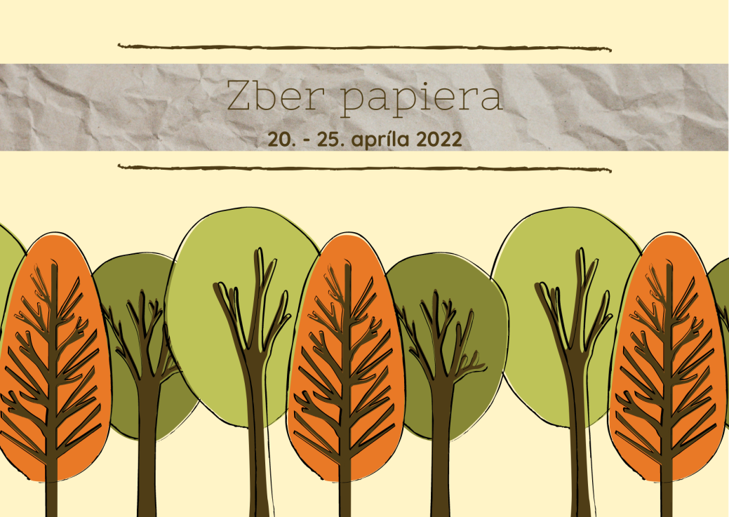
Vyhodnotenie zberu papiera:
Miesto | Trieda | kg
1. | VI.B. | 1426
2. | VII.A. | 763
3. | VII.B. | 694
4. | V.B. | 680
5. | IV.A. | 633
6. | VIII.C. | 585
7. | III.B. | 553
8. | VI.A. | 504
9. | IV.B. | 488
10. | II.B. | 483
11. | III.A. | 453
12. | IX.B. | 442
13. | V.A. | 383
14. | I.A. | 372
15. | II.A | 337
16. | VIII.A. | 304
17. | VIII.B. | 247
18. | I.B. | 239
19. | IX.A. | 154
Spolu |  | 9740

